Institute for Mindfulness-Based Approaches (“IMA”)

In Cooperation with

Transcend International Institute for Mindfulness-Based Approaches (TIMA)

Mindfulness-Based Stress Reduction (MBSR)
MBSR Teacher-Training Programme

Hong Kong

Beginning : November 2016

Description of the MBSR Teacher-Training Programme

What is Mindfulness-Based Stress Reduction (MBSR)?
The MBSR programme was founded in 1979 by Dr. Jon Kabat-Zinn and his colleagues at the Stress Reduction Clinic of the University of Massachusetts, Department of Behavioral and Preventive Medicine, in Worcester, Mass. U.S.A.. MBSR was part of the then-emerging field known today as mind-body or integrative medicine.

MBSR is usually taught as an eight-week course of 2.5 to 3 hour sessions, with a full day of silent mindfulness practice between the sixth and seventh meeting. At its core, MBSR is an intensive training in mindfulness, which Jon Kabat-Zinn has defined as “the awareness that arises by paying attention on purpose, in the present moment and non-judgmentally.”

In an MBSR course, participants are invited to connect deeply to their own lives. Practicing mindfulness means to be present, awake, and aware. It means to be in touch with the moment-to-moment stream of life in a non-judgmental way that reflects kindness to oneself and to the world at large. Rather than avoid or deny a difficult situation, mindfulness supports us to be present in a situation as it unfolds.

Mindfulness has found its most detailed training and study in Buddhist traditions, particularly Vipassana, as well as finding expression in other contemplative traditions. Since the 1970s it has been integrated into Western health care, education and other fields, and has been seen as a non-denominational, non-religious training that is available to everyone, whatever their belief. As Jon Kabat-Zinn notes, mindfulness:

…is a way of looking deeply into oneself in the spirit of self-inquiry and self-understanding…Mindfulness stands on its own as a powerful vehicle for self-understanding and healing. In fact, one of the major strengths of MBSR and of all other specialized mindfulness programs such as Mindfulness-based Cognitive Therapy (MBCT) is that they are not dependent on any belief system or ideology.
MBSR has been successfully implemented in many hundreds of hospitals, clinics, health centers, educational, management and other settings around the world.
A significant number of scientific studies underline the effectiveness of the MBSR program. The studies document impressively that a high percentage of course participants experience one or more of the following results:
- decrease of physical and psychosomatic symptoms
- being able to cope more effectively with stressful situations
- increased capacity to relax
- a growing self-confidence and capacity for self-acceptance
- increased vitality

Three Learning Dimensions of the IMA’s Programme

The process of becoming an MBSR teacher involves immersion in each of the programme’s three learning dimensions.

Cohort Learning  Learning within the same group with various rotating teachers across 5 modules | Individual Learning  One-to-one tutoring with a mentor | Personal Learning  Deepening of one’s own meditation practise

The cohort learning dimension means working within the same group of students with rotating faculty members, and consists of 2 modules of six days, and 3 modules of five days each.

The individual learning dimension is in a one-to-one mentoring process during the teaching of your own 8-week MBSR course. It consists of five individual sessions over Skype.

The personal learning dimension nurtures the deepening of one’s own meditation practice as a resource in developing one’s teaching capacity. This includes daily practice of mindfulness meditation as well as participation in at least one silent 5-day retreat, either before the program starts or during the training program.

Details of the MBSR Teacher-Training Programme

The training programme is strongly structured, at the same time encouraging personal creativity and expression. The multidisciplinary team is committed to each participant finding his/her own identity as a teacher. Each trainee is invited to practice and integrate mindfulness skills in their own daily lives before passing them on to others.
The programme will fully prepare the trainee to teach MBSR by himself/herself. The practically oriented learning units, combined with the individual mentoring sessions as well as the nurturing of one’s own meditation practice, build a three-pronged approach that has been shown to be highly supportive.
Specific elements of the training programme include:
    - Teacher trainees learn and practice the main formal exercises of the MBSR/ programmes: body scan, mindful bodywork based on gentle yoga, sitting meditation and walking meditation, as well as learning how to teach these exercises to others.
    - The training programme emphasizes the deepening of one’s own meditation practice as the basis for teaching others.
    - The curriculum of the 8-week MBSR is examined in detail, and all elements of the weekly course are taught within the training programme.
    - Participants teach their own self-organized 8-week MBSR course during the last section of the training programme, or shortly thereafter.
    - Preparation for leading a course takes place in every module as participants teach each other and experiment with delivering elements of the programmes.
    - Trainees receive a minimum of five, 50-minute, individual, Skype sessions with a mentor during the time they teach their own eight-week course.
    - Trainees write and create their own Audios for each of the main exercises (Body Scan, Mindful Yoga and Sitting Meditation). These exercises will be covered extensively in the training programme.
    - An extensive MBSR teacher handbook specifically designed for the training program is provided
    - A sample handbook for participants of an MBSR 8-week course is available in digital format for trainees to modify and adapt for their own courses.

4

Curriculum of the MBSR Teacher Training Programme

Module 1 (6 days)
Focus of Module 1: Weeks 1, 2 and 3 of an MBSR course

- Immersion in Weeks 1, 2 and 3 of the MBSR course This includes:
- learning and practice teaching of the Body Scan and mindful yoga programs
- Review of other exercises in Weeks including a) the raisin exercise, b) mindful breathing, c) 9-dot exercise, d) mindful-looking exercise,
- Themes taught within each of weeks will be reviewed. These include:
  - What is mindfulness?
  - Working with boundaries
  - Mindful breathing to support presence
  - The role of perception in stress, etc.
- Extensive practice teaching of each exercise with supervision from IMA teachers
- Introduction to inquiry – the art of leading exploratory dialogue and group discussion
- Facilitating inquiry in practice sessions

5
Module 2 (6 Days)
Focus of Module 2: Weeks 4 and 5 of an MBSR course

- Review of Yoga practice and teaching
- Immersion in Weeks 4 and 5, including the sitting meditation
- Extensive practice teaching of the sitting meditation in dyads and triads
- Reflection on the content and structure of the MBSR/ sitting meditation. Aspects of guiding meditation, potential problems for participants and for the teacher
- Introduction to walking meditation and how to teach it
- The pre-interview for an MBSR course. Structure, sample questions, etc.
- Indications and contraindications for participation in an MBSR course
- Deepening of Inquiry (Mindful Dialogue) practice
- How to teach the themes of Week 4 and 5 including:
  - What is Stress?
  - Stress-aggravating and stress-reducing thoughts, and how to work with them
  - Brief look at stress theory and research as well as the practical details of how to teach stress theory in an MBSR course

6

Module 3 (5 Days)
Focus of Module 3: Week 6 and the Day of Mindfulness

- Immersion in Week 6 of the MBSR course including:
  - The communication exercises (experiencing and practice teaching)
- Introduction to Insight Dialogue
- The Day of Mindfulness will be taught in its entirety
  - Trainees will experience a full-day of mindfulness as it is taught in the MBSR program
  - In addition to the mindfulness exercises already learned, trainees will learn to teach the new exercises of the Day of Mindfulness including
    - Mountain meditation
    - Metta (Loving Kindness) meditation
    - Crazy Walking exercise
- Deepening of Inquiry through practice and discussion
- Theme: What is healing about mindfulness? Exploring one’s personal experience as well as theoretical considerations
- Reviewing research on the effectiveness of mindfulness, particularly in working with stress themes and emotions
- Consideration of the role of mindfulness and its teaching in various settings including the sectors of health, education, management and work environments

7

Module 4 (5 Days)
Focus of Module 4: Weeks 7 and 8 of an MBSR course

- Immersion in Week 7 & 8, including detailed practice of and discussion of exercises
- Exploring one’s own motivation to teach MBSR
- The role of the MBSR teacher: Embodying mindfulness
- Differences between MBSR and psychotherapy; the therapeutic/counseling stance and the stance of the MBSR teacher
- Working with "difficult" participants and themes related to this (e.g. transference/ counter transference, etc.)
- Mindfulness and emotions. Theoretical and practical aspects of dealing with emotions in an MBSR course. Guiding participants in being with their emotions mindfully. Emotional intelligence of the MBSR teacher, and why it is so important
- The post-interview for an MBSR course. Structure, sample questions, etc.

8

Module 5 (5 Days)
Focus of Module 5: Deepening Teaching Skills and Going Forth
- Supervision of topics that arise while teaching an MBSR course
- Working with personal suffering and that of MBSR course participants
- Deepening Inquiry Skills
  - The role of insight in MBSR courses and how an MBSR teacher cultivates its development through inquiry
- Qualities of mindful teaching
- The teacher-student relationship, code of ethics and other themes
- Discussion of final projects and student presentations
- How does an MBSR teacher take care of his/her own well-being?
- Closing of the training programme.

Participation Requirements for the Hong Kong MBSR Teacher-Training Programme
    - Successful completion of a professional education or training programme in the fields of mental health, medicine, education, health care, work, physical therapy, occupational, art, & music therapy, nursing, counseling, coaching, human resources, mediation, pastoral work and related professions. Please check with us if you are not sure whether you qualify.
    - At least 1.5 years of sitting meditation practice (Vipassana, Zen, Shambhala Training, Dzogchen, Christian, Contemplative, Sufi, Yoga, etc.) before starting the training programme.
    - Participation in at least one, five-day silent meditation retreat. If you have not yet participated in a retreat, you will be asked to fulfil this requirement within the training programme. We can assist you with recommendations
And
    - Regular sitting meditation practice
    - Minimum Age: 30
The IMA encourages older professionals to apply. In our training programme an ever increasing number of persons 55 + are taking part with the idea of teaching MBSR/ after they retire or work less.
    - Some experience in meditative bodywork, particularly yoga. If you do not have any yoga experience, or we feel you can benefit from additional training, we will ask you to take part in a weekly yoga course in your home town during the training programme.

Please Note:
Participation in an 8-week MBSR course is a also a requirement

We encourage you take part in an MBSR 8-week course before the start of the training.

If you are geographically too far away from a weekly course offering, or your work schedule does not permit it, it is possible to take part in an online 8-week MBSR course approved by the IMA either before or during the first five months of the training programme. If you are accepted into the programme and have not yet done such a course, we will ask you to participate in a course as a condition of acceptance

If there is a sufficient interest, the IMA will offer a live, on-line MBSR course with one of its faculty members for trainees in its MBSR teacher-training program. There will be an additional charge for this program.

Certification

Requirements for Successfully Completing the Training Programme and Receiving an MBSR teaching certificate

ALL persons who successfully complete the training programme according to the terms specified in the enrolment contract will receive a certificate as an MBSR Trainer.
Successfully completing the training includes:
- Teaching one’s own self-organised eight-week MBSR course during the last part of the training programme.
- Mentoring: A minimum of five, individual telephone sessions with a Mentor approved by the IMA during the teaching of one’s own 8-week course is required. If the mentor deems it necessary, additional mentoring sessions may be required.
- Completion of a final thesis, including a detailed reflection of the teaching of one’s own 8-week MBSR course.
- Preparing one’s own audio versions of the Body Scan, Sitting Meditation and Mindful Bodywork/Yoga and submitting them with the final thesis.
- Submission of the student handbook used in the trainee’s own MBSR course with the final thesis.

11
Faculty of the MBSR Teacher Training Programme
Members of the Hong Kong Teacher Training originate from: Ireland, The Netherlands, Germany, and the U.S.

The IMA´s faculty includes some of Europe’s most senior teachers and trainers in mindfulness-based approaches. The high level of professionalism and experience of the institute’s teaching staff is a highlight of the training programmes. All our faculty members have a personal mindfulness practice extending over many years as well as having extensive professional experience in the integration of mindfulness-based approaches in their own professions.

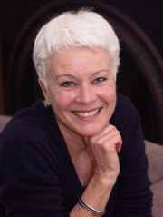 | Eva Bruha, is the manager and resident teacher at Kalyana Centre, Dingle, Co. Kerry. She has spent over 20 years practicing Mindfulness Meditation and spent all together more than 3 years in intensive silent retreats in Meditation Centres in Burma, Thailand, Europe and the U.S. She now lives at Kalyana Centre in Dingle and offers MBSR courses, classes and retreats to those interested in awareness practices.  Eva's goal is to make Mindfulness Meditation accessible to everyone, regardless of age and cultural or religious background. She completed her training as an MBSR teacher with the IMA.
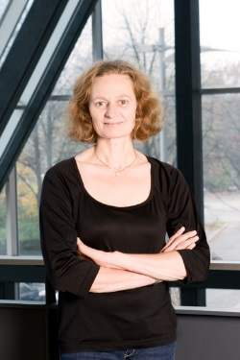 | Sagra Hannich is an MBSR & MBCT Teacher. She has a Diploma in Sport (Area of specialization: Prevention and Rehabilitation) and is a Naturopath for Psychotherapy. She has many years work experience with cardiac patients in clinical settings. Since 2009 she is a member of the staff of the Asklepios Clinic in Hamburg, Germany, where she teaches MBSR and MBCT in the day clinic for stress medicine. She completed her training as an MBSR and MBCT teacher at the Institute for Mindfulness-Based Approaches, as well as further  trainings with Jon Kabat-Zinn and Saki Santorelli. Her personal meditation practice of almost 30 years is in Zen, Vipassana and meditative movement.
111
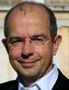 | Günter Hudasch, has a degree in Biology and worked for 16 years in organizational development in a government environment administration. In 1998 he joined Julia Augustine & Partner, a management consulting company, where he specialized in organizational development, coaching and consulting. He is trained in organizational development, NLP, Gestalt counselling, Gestalt therapy, and he has qualified to work as a psychotherapeutic counsellor. He began working with MBSR in 2000 and completed his MBSR teacher training in 2005 at the Institute for Mindfulness-Based Approaches. He has taught many 8-week MBSR courses. His focus is, however, on mindfulness trainings in companies, where he also offers mindful-leadership programmes. He is at present teaching mindfulness within a research project at the Max-Planck-Institute for Social Neuroscience in Leipzig. He has served as president of the German MBSR Teacher Association since it was founded in 2005.
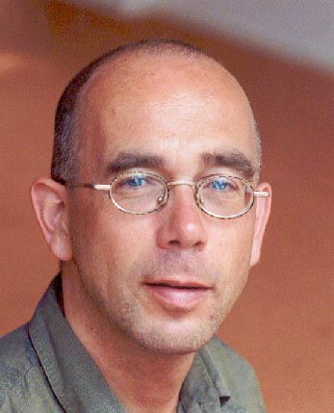 | Frits Koster works as a mindfulness trainer in mental health settings. He has a degree in psychiatric nursing and is a teacher of MBSR. He teaches at the Institute for Mindfulness in Rolde, Netherlands and in the postgraduate mindfulness Programme at the University College Artevelde in Gent, Belgium. He began practising insight meditation in 1979. He ordained as a Buddhist monk for six years, practising Vipassana meditation and studying Buddhist psychology in meditation centres and monasteries in Thailand and Burma. In 1988 he returned to the Netherlands, where he has been facilitating meditation activities ever since. He has written several books; two of which in English: Liberating Insight and Buddhist Meditation as Stress Management. He is a co-founder, with Dr. Erik van den Brink, of Mindfulness-Based Compassionate Living (MBCL), an 8-week compassion-training program, described in detail in a book by that name published by Routledge in 2015.He completed his training as an MBSR teacher at the Institute for Mindfulness in Rolde, Netherlands.  Netherlands.

13
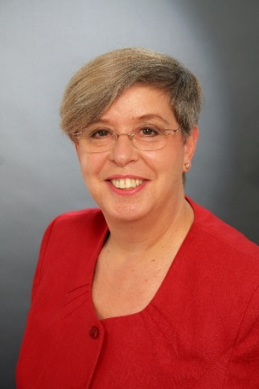 | Linda Lehrhaupt, Ph.D. is the Founder and Director of the Institute for Mindfulness-Based Approaches (IMA). With almost 35 years as a teacher and supervisor in mindfulness-based approaches, she has a rich background in their integration in education, health care and personal development. She began teaching Mindfulness-Based Stress Reduction (MBSR) in 1993 and has been training MBSR teachers since the founding of the IMA in 2001. She is certified to teach MBSR from the Center for Mindfulness (CFM), and holds a Ph.D. in Performance Studies and a degree in education. She has been a teacher in adult education for almost 45 years, specializing in curriculum development and interdisciplinary approaches. Dr. Lehrhaupt began practicing Zen meditation in 1979 and has received full authorization as a Zen teacher in the White Plum Lineage of Taizan Maezumi Roshi. She has been leading meditation retreats internationally since 1992. In 1976 she fell in love with Taiji and Qigong and went on to train with some of the leading representatives of the first generation of Asian teachers in the West. For over 20 years beginning in 1982 she directed innovative teacher-training programs in Taiji and Qigong, including Europe’s first training program in Qigong and women’s health. She is the Co-Author of Mindfulness-Based Stress Reduction: The MBSR Program for Promoting Health and Vitality (2015) and author of Tai Chi as a Path of Wisdom (2001). She is also the author of Riding the Waves of Life: Mindfulness and Inner Balance (in German, 2012). Dr. Lehrhaupt, who was born and grew up in New York City, has been living with her family in Germany since 1983.
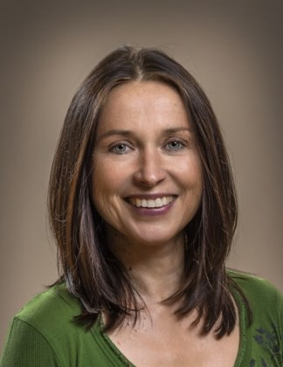  131414Page 14 | Katharina Meinhard is a physiotherapist and director of a Yoga teacher-training programme certified by the German Association of Yoga Teachers. She is the Co-Director of the Yoga School of Dresden and has been teaching Yoga since 1992 and MBSR since 2003. She is a graduate of the training programme at the Institute for Mindfulness-Based Approaches. She began practicing Zen meditation in 1990. Since 1989 she has worked extensively in health maintenance and rehabilitation programmes, with a strong emphasis on mindfulness-based bodywork in clinical settings.
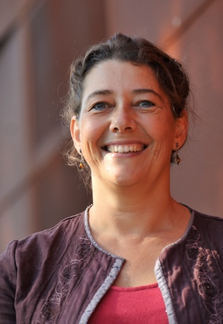 | Ingrid van den Hout completed her study of the Science of Human Movement at the Free University of Amsterdam in 1989. She works as a psychomotor therapist in mental health care. She is also a teacher of MBSR, MBCT and Breathworks. She has a background in the martial arts (Aikido) and became a practitioner of Vipassana in 2001. She trained as an MBSR teacher at the Center for Mindfulness (CFM) in the U.S. in 2004 and 2005. Continuing her development as an MBCT teacher, she participated in the Advanced-Training for MBCT offered by the University of Bangor in 2008. She acted as senior teacher and assessor during a multi-clinic study on MBCT by Radboud University. Since 2006 she has been on the faculty of the Dutch Institute for Mindfulness as a trainer of MBSR and MBCT teachers. She completed her formal training as a supervisor at the British Centre for Supervision and Team Development in 2013. Her involvement in psychosomatics led her to train as a teacher of Breathworks. Currently she serves as a Breathworks associate for The Netherlands and as a trainer and supervisor for the British Breathworks Organisation.

15

Dates, Fees and Venue

Dates for the Hong Kong Teacher Training

Module 1: 08. – 13. Nov. 2016

Module 2: 21. – 26. Feb. 2017

Module 3: 24. – 28. May 2017

Module 4: 06. – 10. Sept. 2017

Module 5: 16. – 21. Jan. 2018

Venue for the Teacher-Training Programme (Non-residential)

NAME AND ADDRESS OF VENUE TO BE ADVISED LATER

Times of Seminars:

9:30 – 18:00 All Days except last day of each Module

9:00 – 15:30 Last Day of each Module

Teacher Training Course Fee: HKD 54,000
The course fee includes all instruction plus two handbooks. The fees do not include either the mentoring sessions (which are paid directly to the Mentor) or housing and meals during the training programme.

Fees for Mentoring
The fees for each mentoring session range from ca. 675 HKD to 850 HKD per session, depending on the Mentor and in what country he/she lives.

Fee for Live, Online MBSR Course if trainee chooses to participate in one. This will be decided upon at a later date. Its offering depends on there being a sufficient number of applicants (minimum 8).

Number of Course Participants: Maximum 32

Further Information: The Transcend Institute for Mindfulness-Based Approaches (TIMA) is responsible for the organization, registration and administration of the training program in Hong Kong. Please contact us with any questions at : enquiry@tiimba.com or leave a message at +852 96129111.

Transcend Institute for Mindfulness Based Approaches Office Address :

Transcend International Holdings Limited
19th Floor, Silver Fortune Tower
1 Wellington Street,
Central
Hong Kong

2

